Team Pages Guide

Accessing Your Team Page

Before you can login to your team, you MUST be added as a Team Staff member within the Club registration system with the role of Coach, Assistant Coach, or Team Manager, have an approved registration status, and a valid email address. Note: If you are unable to login, please reach out to your Club Admin to request to be added as a Team Staff member.

Logging in to Your Team Page

To log into your team page, navigate to the public team page posted on your league’s website. When you view the league schedule, you will see a list of teams participating in the current season for your league. You can access your team page from the schedule by clicking on the name of your team.

Click your team name:

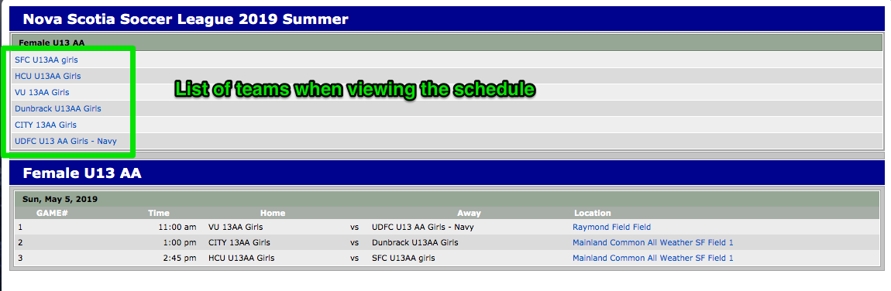

On the right hand side of the page click the “Team Log In” button:
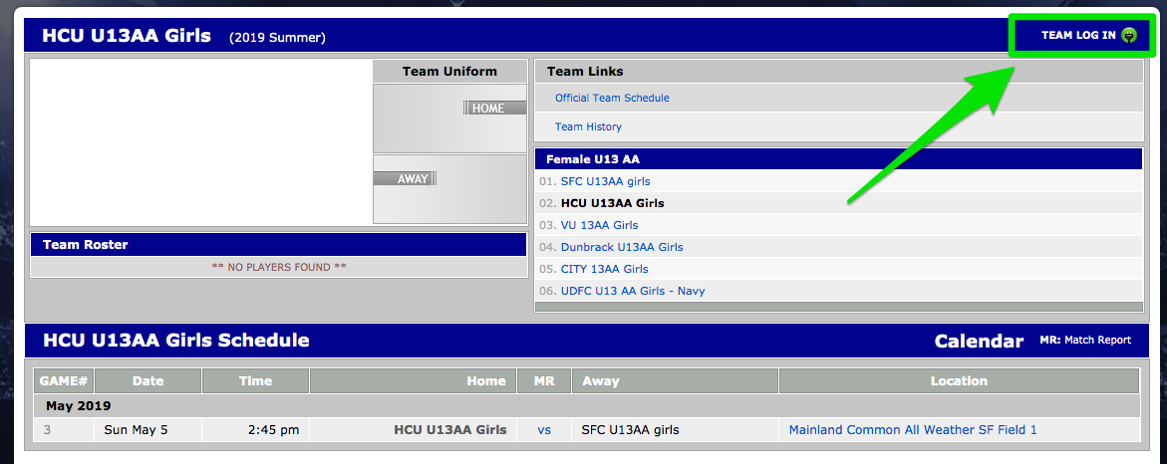
Click the “click here” link to retrieve your PIN to log in if you don’t have one or don’t remember. NOTE: This pin is different from the password used to access your household account.
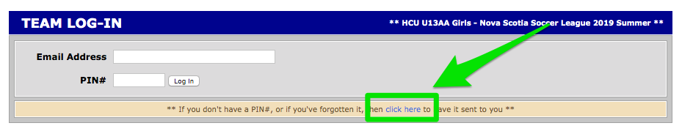
Enter the email associated with your Demosphere account and click “Submit”. Note: The email address should be the same email used when registering with your club or the email you provided to the club when requesting they add you to the team roster.
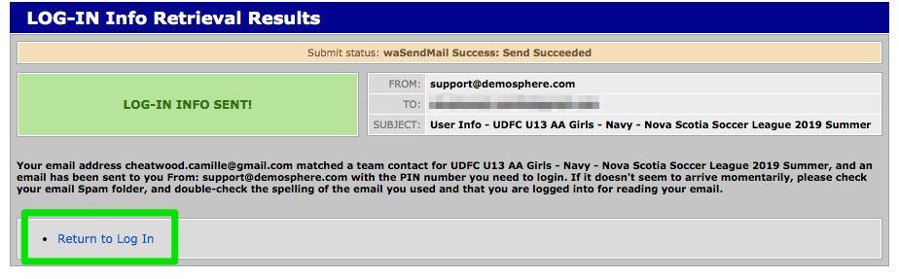
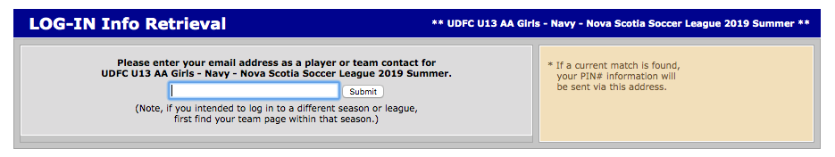
The system will verify you are listed as a team contact and you will see the message below. Click “Return to Log In”. Note: If the email you entered DOES NOT match the email on file with the club, you will receive a message indicating the user is not found and you need to contact your club to verify the email on file.
You will be sent the pin needed to log into your team page via email. The email will be from support@demosphere.com:
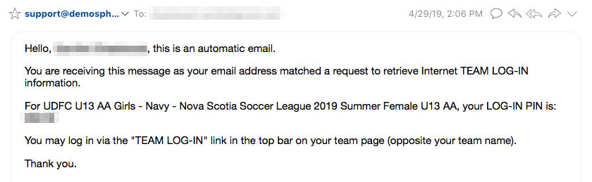
Enter your email and the pin you received via email:
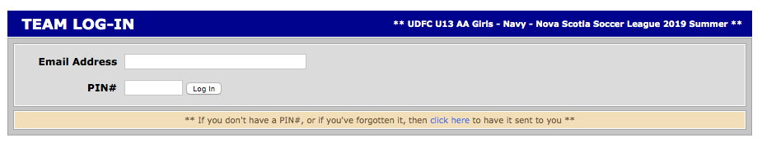
Once you log in, you will be brought to your team start page. Here you can:

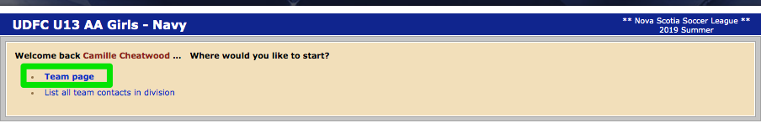
- Access your team page. Click “Team page”.

Maintaining Your Team Page
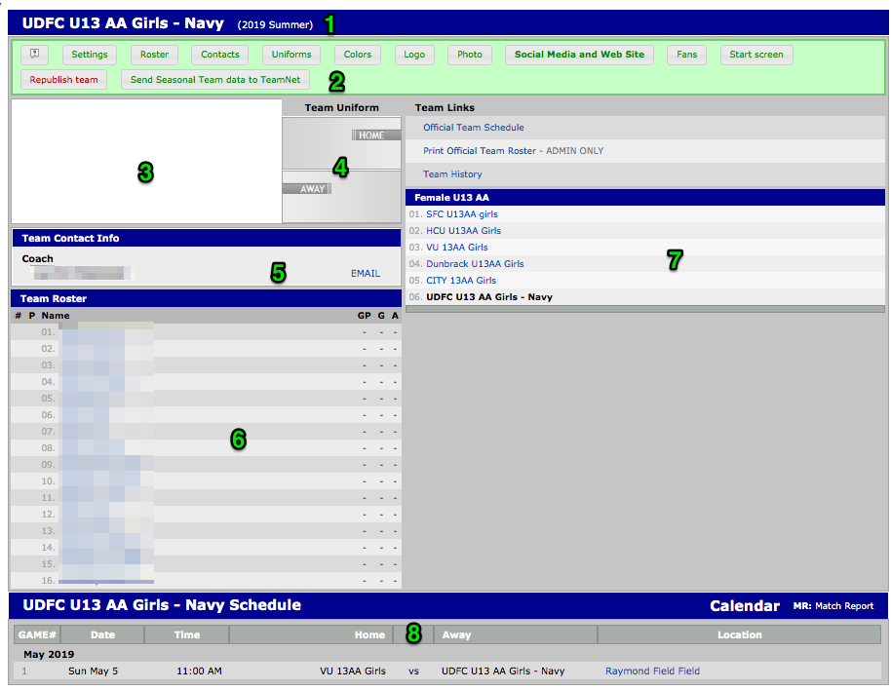
Here are some key features about your team page:
- This is your team name and the current season
- This is the team page toolbar team admins see when they log in.
- If you upload a logo for your team, it will display here.
- If you set uniform colors for your team, they will display here.
- This is the list of team contacts for your team that have synced from your Club system. Contact your Club Admin if additional team contacts should be added.
- Here is the list of players for your team (your roster). The roster is maintained and locked via the Club Registration system. If you need to make any changes to your team roster, please contact your Club Admin. NOTE: You do have the ability to add guest players to your team for a specific game, addressed below.
- This is where the standings for your division will display.
- This is the schedule for your team. If needed, you can export the schedule by clicking on the “Calendar” link.
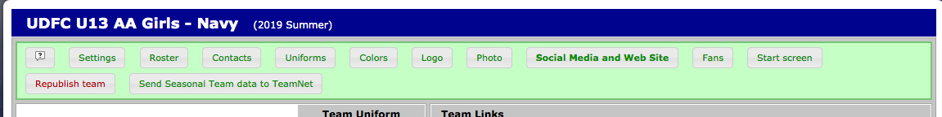
As an admin for the team, you have the option to adjust your team page settings by using the tools in the green toolbar:
Adjust the settings for your team page by clicking “settings”:
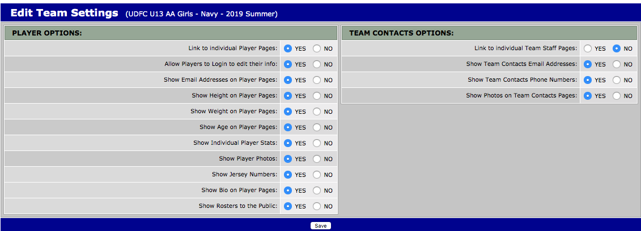
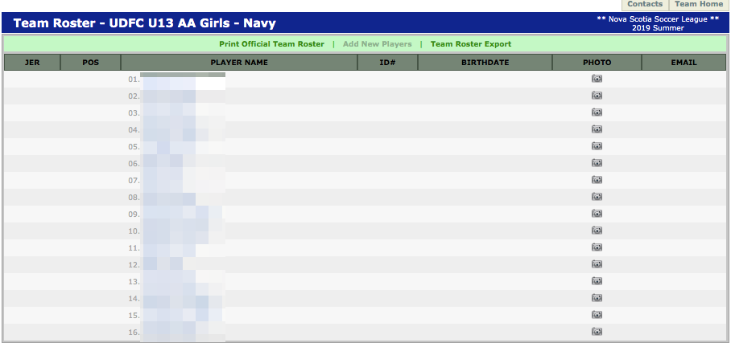
You can view the roster from your team page but also view it by clicking “roster”:
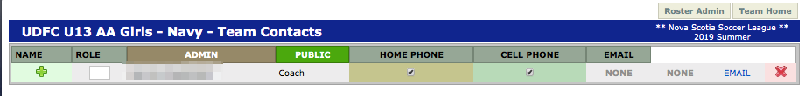
You can view your team contacts on the team page but can also view then by clicking “contacts”.
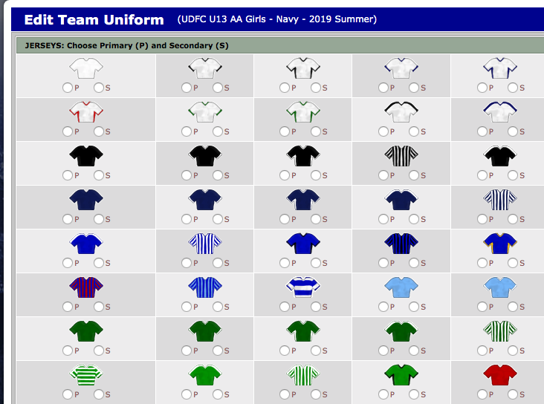
You can set the uniform for your team by clicking “uniforms”:
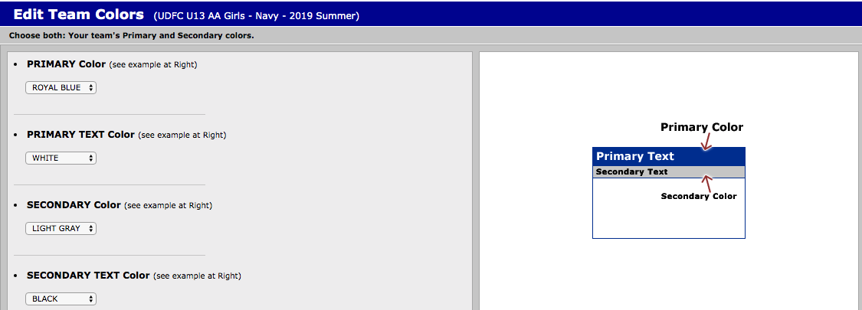
You can edit your team colors by clicking “colors”:

Click “logo” to upload a logo for your team
Click “photo” to upload a photo of your team

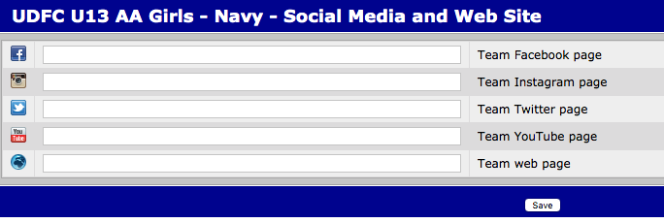
You can add your website and social media links for fans by clicking on “social media and web site”:

Edit Player Jersey Numbers
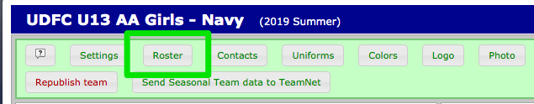
From your team page, click on “roster” in the green box.
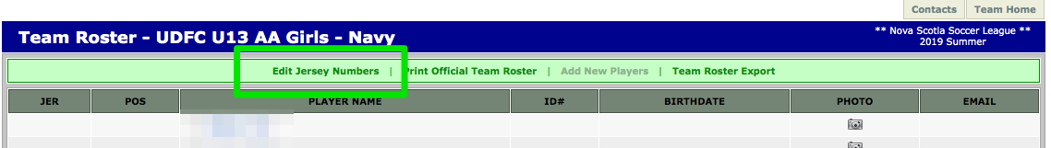
At the top of the page, in the green box, click the button “Edit Jersey Numbers."
When you click this button, a dialogue pops up for the editing of all players jersey numbers. Enter the jersey numbers for each player and click “save.” The jersey numbers will now attach to the players and print on the game cards.

Edit My Team Schedule
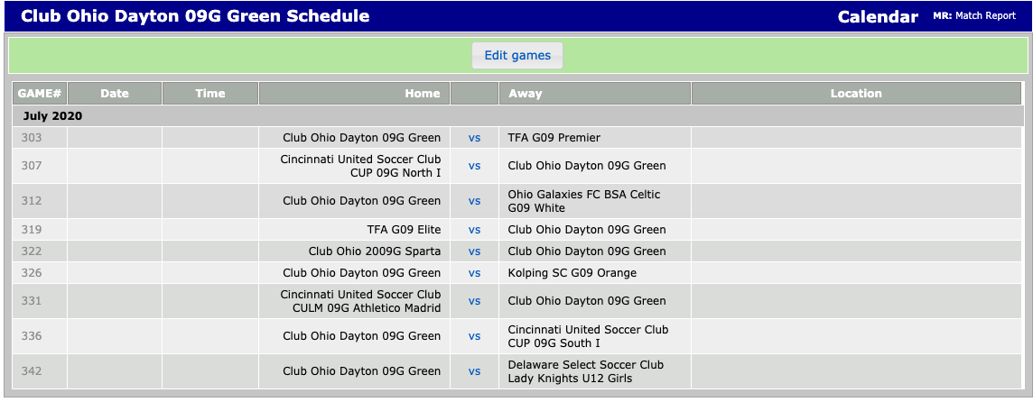
To Edit your team schedule, click the “Edit games” button on the schedule to change your home games to an editable format.

Click the “TBD” on the schedule to enter the date, time and location. Then click “save.”
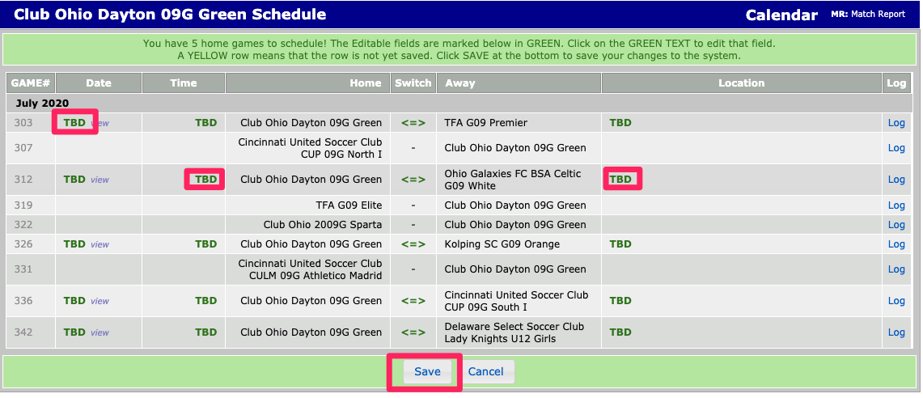

Add Guest Players
Scroll down to the team schedule on your team page and click on the “vs” for the game you wish to add a guest player to the roster:
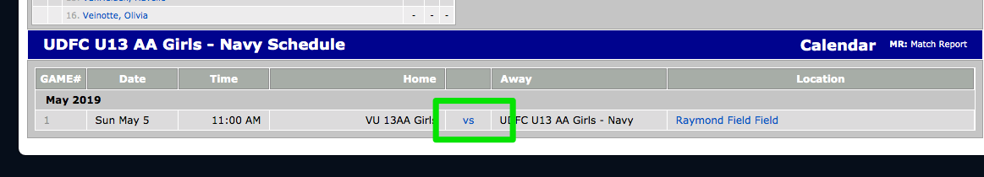
On the next page, click the ‘Add Eligible Players’ link:
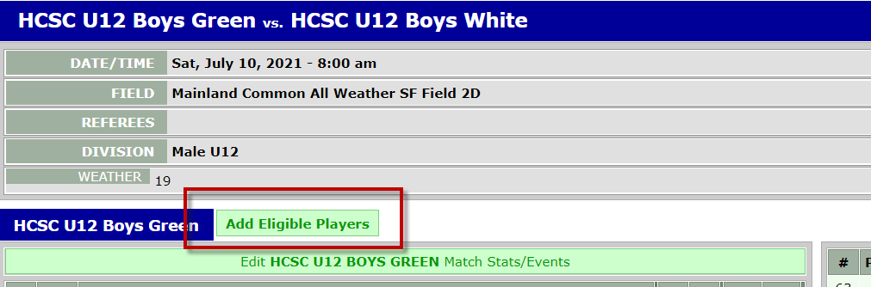
Finally, check off the guest players that you’d like to add to this game’s roster before clicking the save button at the bottom of the page.

Print Game Cards
Scroll down to the team schedule on your team page and click on the “vs” for the game you wish to print the game card for:
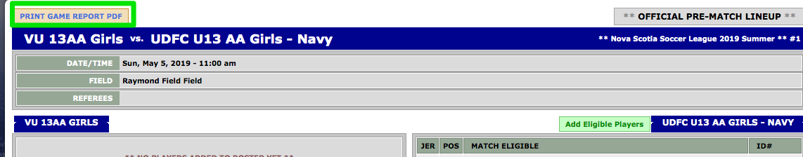
Click “Print Game Report PDF”:

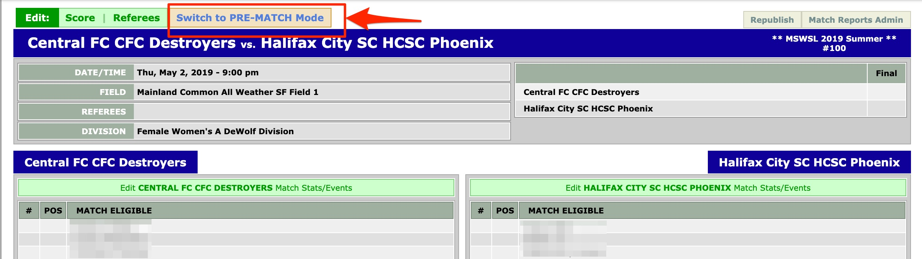
If you are trying to print the game card the DAY OF the game, you will first need to switch to the Pre-Match Report view:
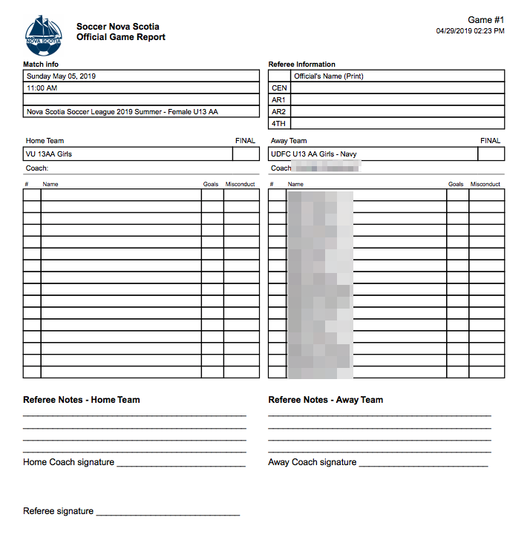
Print the game card for your game:

Score Reporting for Teams

*Please refer to your league policies on score reporting. Not all leagues use the Demosphere score/match reporting functionality.

To report your score, from the start screen when you log into your team page click “home games” or “away games”.
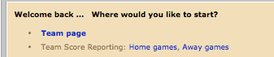

If you are already logged in, you can click “start screen” from your green toolbar navigation.

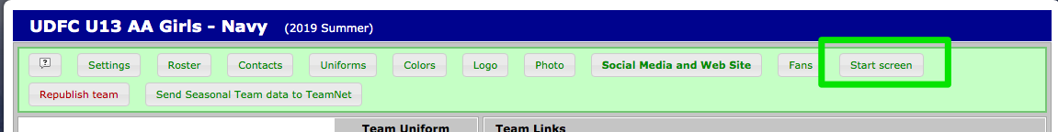

Enter the score for the game and click “save”.

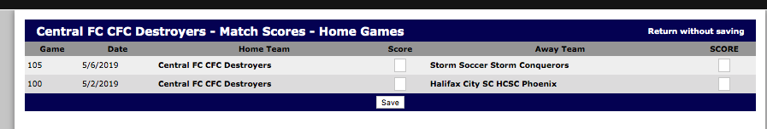

Post-Match Reporting for Teams

Log into your team page and click “team page”.

On the schedule, click the “vs” or the score if already entered.

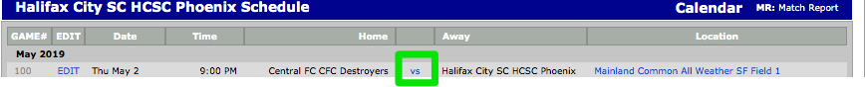

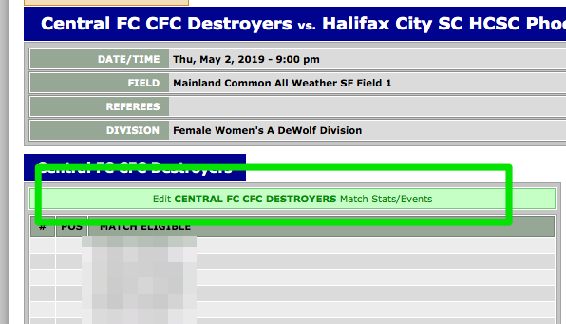
Click the “edit match stats/events” for the team you need to enter stats for.

Update any jersey numbers and fill out any disciplinary cards that were received.
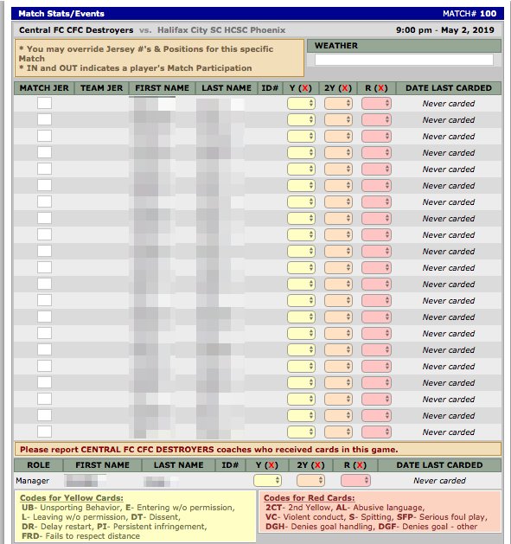
To record goals and/or assists, you will see a dropdown to select from among your players for each goal that was recorded when you entered the score in Step 2:
